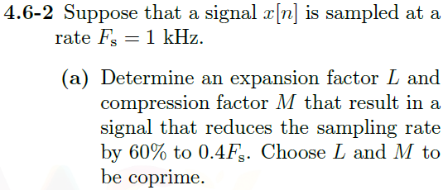

Let L = 2 and M = 5 then the sampling rate $F_{s}$ will change to be $\frac{L}{M}F_{s}=\frac{2}{5}F_{s}=0.4F_{s}=400Hz$

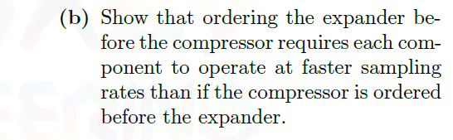

If $f_{s}$ is our sampling frequency at 1kHz. Then by expanding by a factor of L = 2 we are now operating at a frequency of $2*1kHz=2kHz$. Then when we compress by a factor M we are operating at a frequency of $\frac{2kHz}{5}=400Hz$

Now if we compress first by an example of M = 5 we will be operating at a frequency of $\frac{1kHz}{5}=200Hz$. Then expanding by a factor of L = 2 brings us to $200Hz*2=400Hz$.

By expanding first we are requiring our components to operate at a faster 2kHz frequency.